**Linux Lab - 03**

1. **ln command:**

**Syntax:** ln[OPTION]... [-T] TARGET LINK_NAME

**Example:** 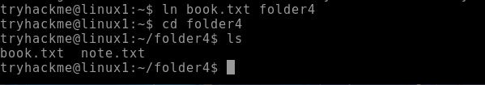

1. **rm command:**

**Syntax:** rm[file_name]

**Example:** 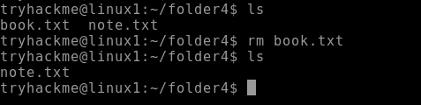

1. **rev command:**

**Syntax:** rev[option] [file]

**Example:** 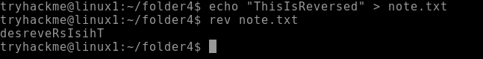

1. **paste command:**

**Syntax:** paste[option] [file]

**Example:**

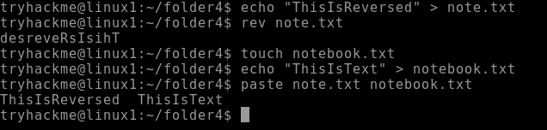

1. **cmp command:**

**Syntax:** cmp[file1] [file2]

**Example:**

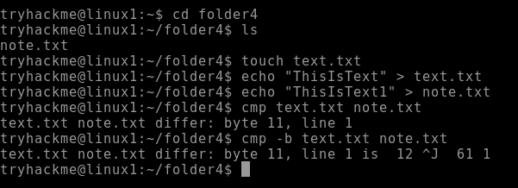

1. **id command:**

**Syntax:** id[option] [user]

**Example:** 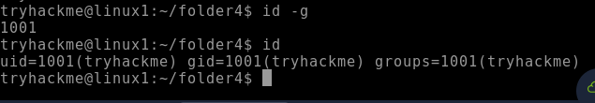

1. **chmod command:**

**Syntax:** chmod[option] [mode] [file_name]

**Example: **

1. **whoami command:**

**Syntax:** whoami

**Example: **

1. **kill command:**

**Syntax:** kill [signal] PID

**Example:**

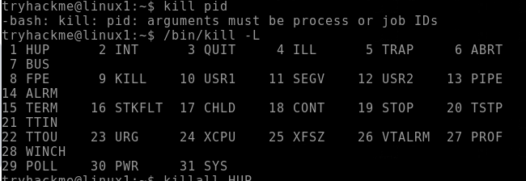

**10. wc command:**

**Syntax:** wc [option] [file]

**Example:**

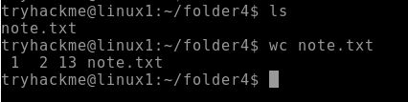

**11. head command:**

**Syntax:** head [option] [file]

**Example:**

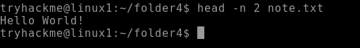

**12. id command:**

**Syntax:** id [option] [username]

**Example:**

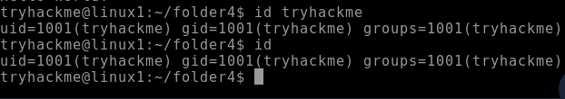

**13. tail command:**

**Syntax:** tail [option] [file]

**Example:**



**14. touch command:**

**Syntax:** touch [file]

**Example:**



**15. more command:**

**Syntax:** more [option] [file]

**Example:**



**16. less command:**

**Syntax:** less [option] [file]

**Example:**

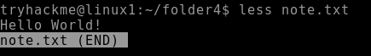

**17. ps command:**

**Syntax:** ps [options]

**Example:**

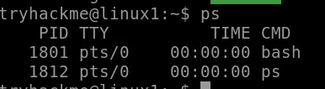

**18. cp command:**

**Syntax:** cp [options] source…destination

**Example:**



**19. mv command:**

**Syntax:** mv [options] source…destination

**Example: **

**20. cat -n command:**

**Syntax:** cat –n[filename]

**Example:**

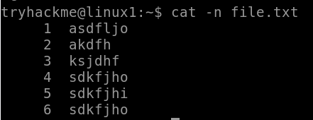

**21. cat >> command:**

**Syntax:** cat [filename1]>>[filename2]

**Example:**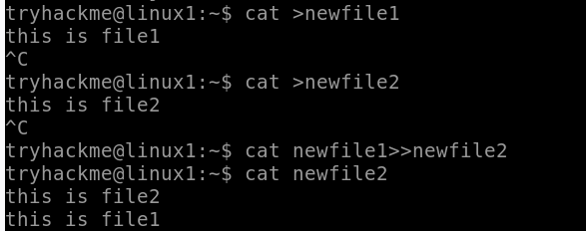

**22. join command:**

**Syntax:** join [option]…[file]…

**Example:**

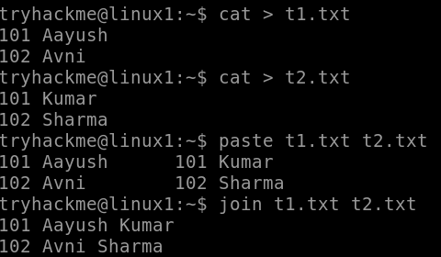

**23. wc -l command:**

**Syntax:** wc -l [option]…[file]…

**Example:**



**24. ifconfig command:**

**Syntax:** ifconfig [interface] [option]

**Example:** ifconfig cd

**25. ls -a command:**

**Syntax:** ls [option] [file]

**Example:**



**26. ln command:**

**Syntax:** ln [option] [-T] target link_name (1st form)

ln [option] target directory (2nd form)

ln [option] –t directory target (3rd form)

**Example:** ln program.py link.py

**27. killall command:**

**Syntax:** kill [signal] PID

**Example:** killall –l

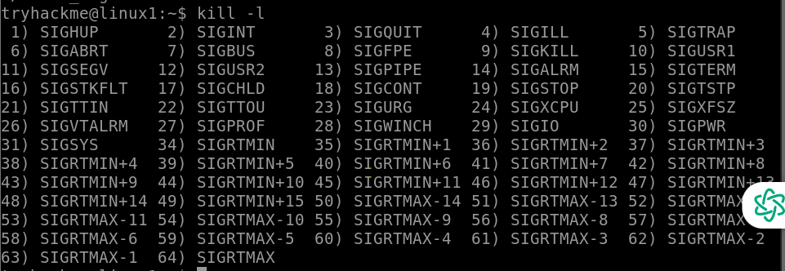

**28. kill command:**

**Syntax:** kill [signal] PID

**Example:** kill -91188

**29. ps command:**

**Syntax:** ps [option]

**Example:** ps ef

